# **State Reduction and Counters**

**State reduction**

<https://www.youtube.com/watch?v=PxPU3zb8TRY>

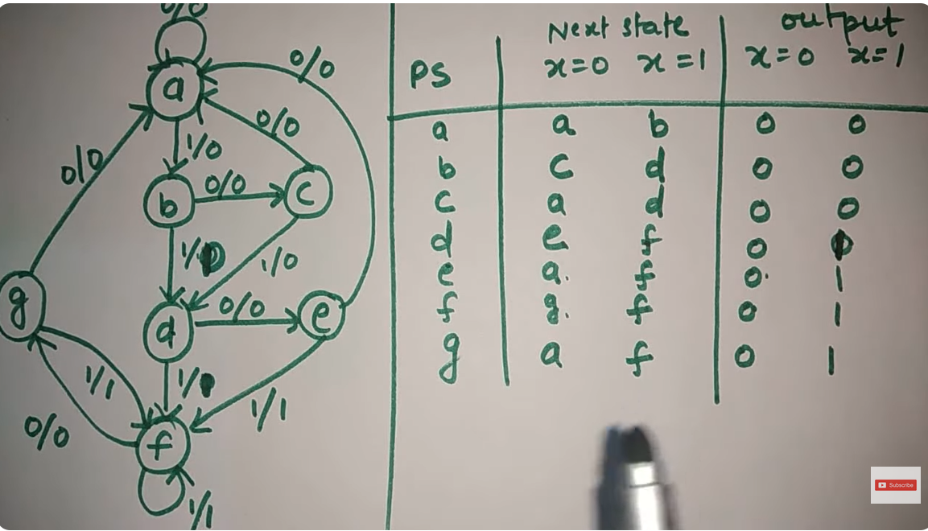

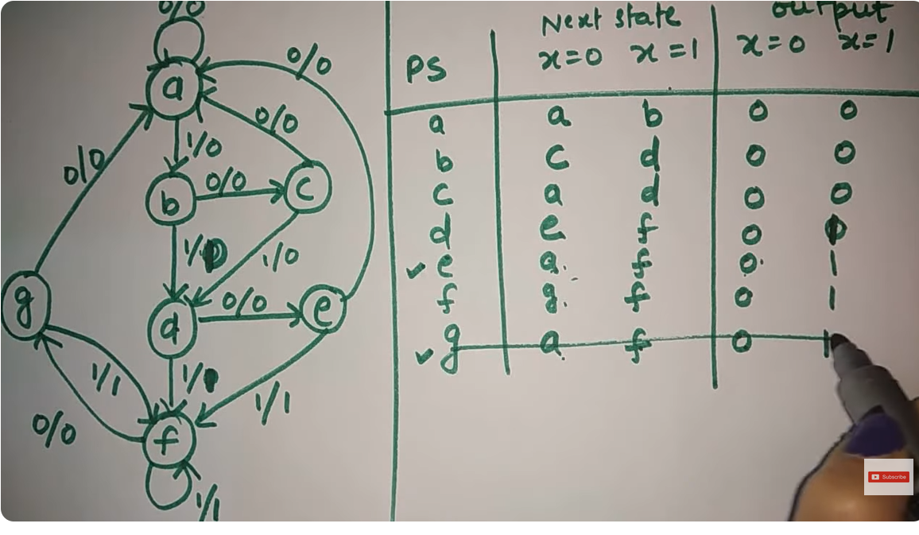

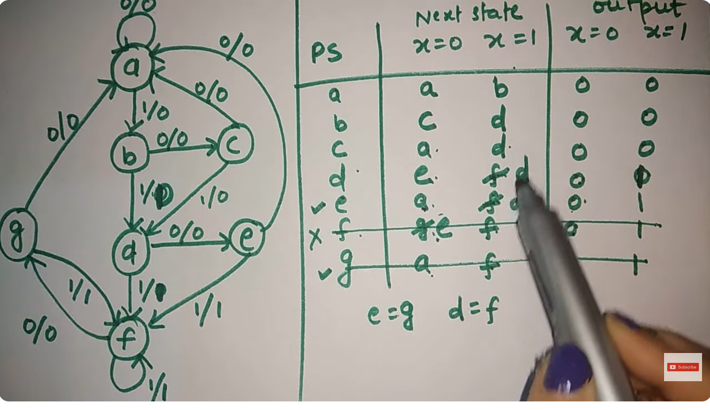

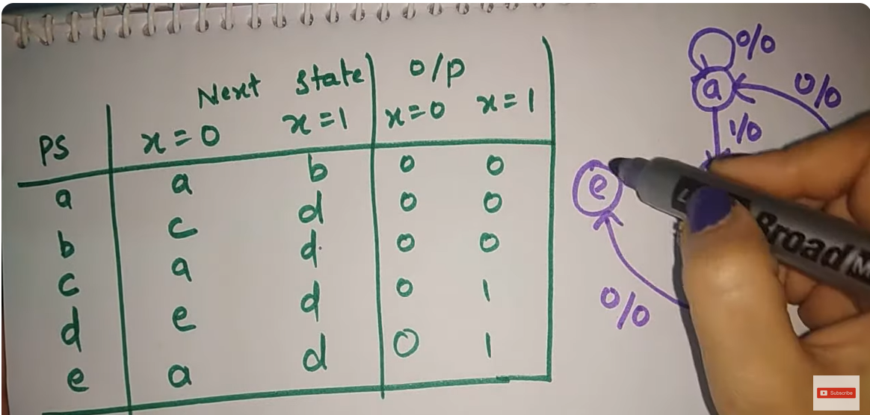

**Practice**

Reduce following diagram’s state diagram

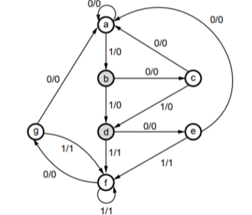

**Counter**

<https://www.youtube.com/watch?v=Mxfsl5dhsyo&t=17s>

A device that count is any order, ascending or descending. Used in oven, ac

Mod counter er mod ki?

Mod-277 e koyta flip flop lagbe?

10 to 99 in decimal gunte koyta flip flop lagbe?

Flip flop numbers=Ceil(Log2 base)

Counter er mod = distinct counts

**Synchronous asynchronous**

<https://www.youtube.com/watch?v=sdQO4ryAovs&t=39s>

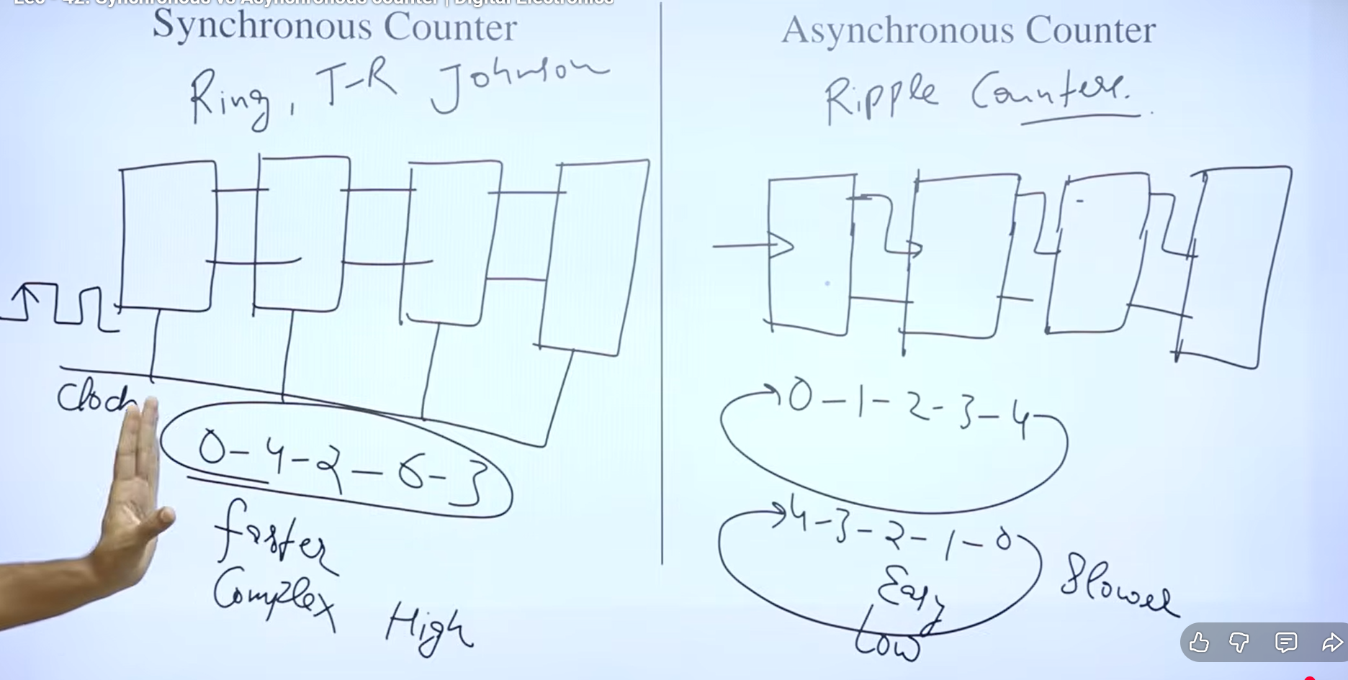

**3 bit asynchronous up counter**

<https://www.youtube.com/watch?v=s1DSZEaCX_g&list=PLuYnCh-Sh1Xd5cLa-CfK883tPmJwrjSwF&index=3>

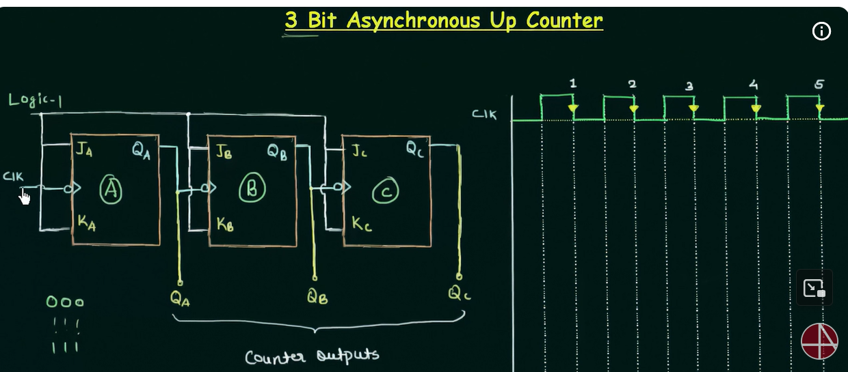

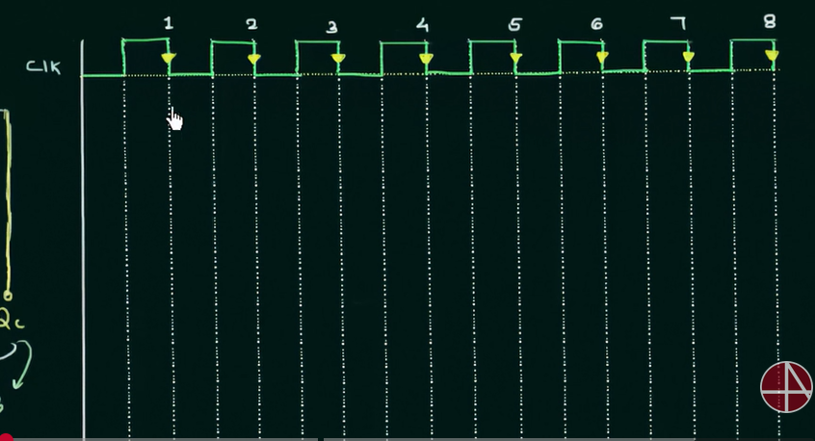

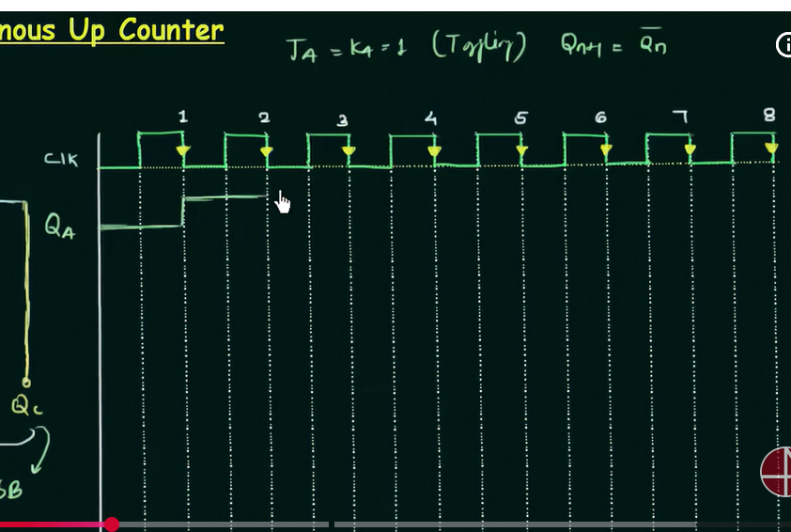

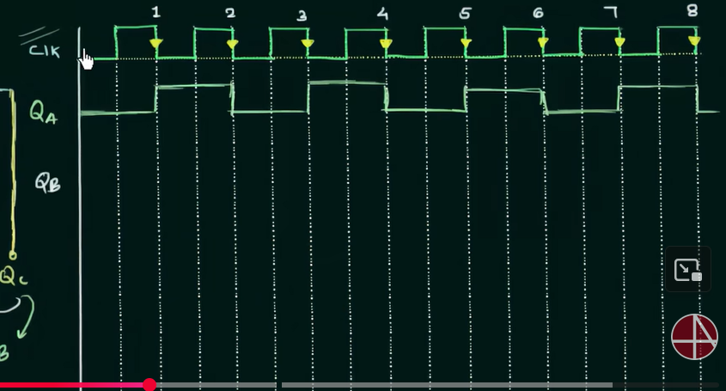

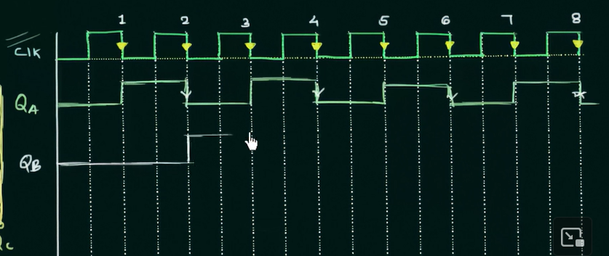

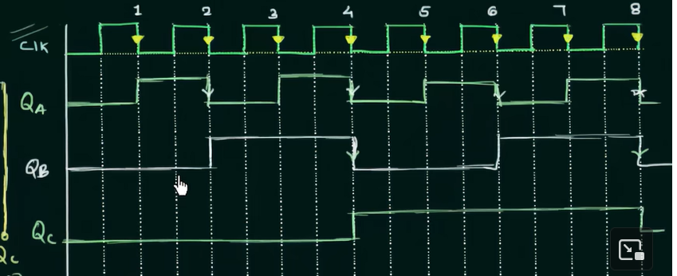

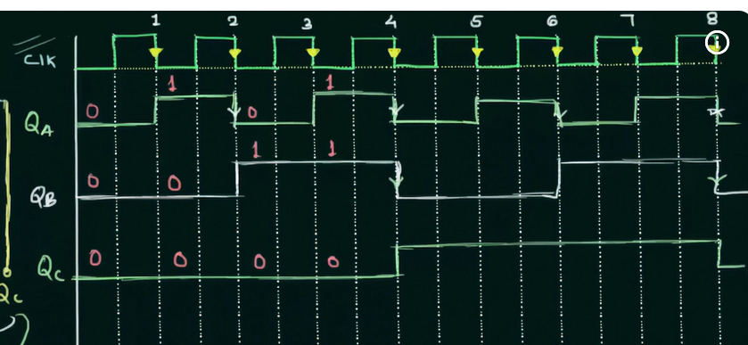

Down counter

Ripple

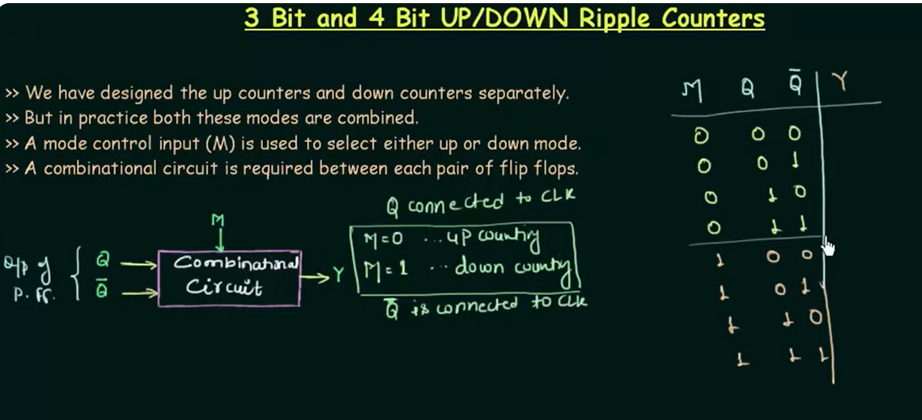

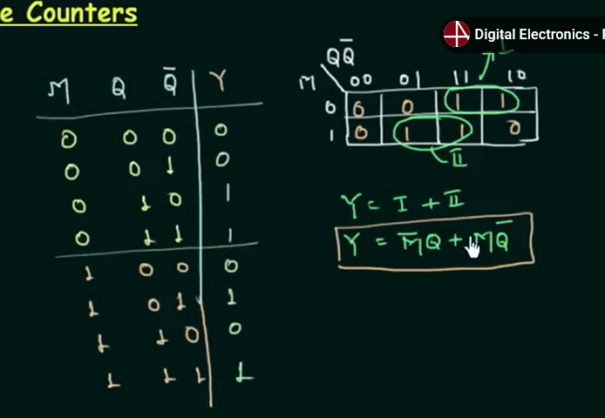

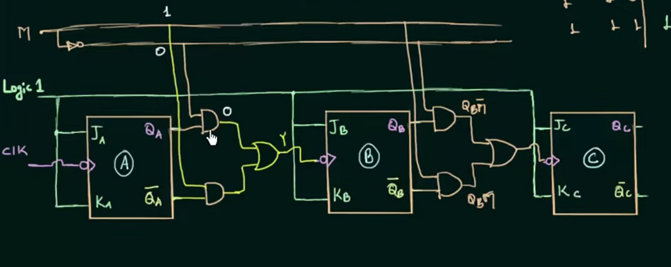

Decade or Mod-10 counter

